Project Plan

Canvas MCP
CY2 IT Services B.V.

Date | March 2026
Version | 1.4
Status | In Development
Authors | D. Pasecinic, K. Secen, I. Zhechev
Version Control
Version | Date | Author(s) | Amendments
1.0 | 14/03/26 | I. Zhechev, D. Pasecinic | Initial draft.
1.1 | 16/03/26 | D. Pasecinic, I. Zhechev | Table of contents, page numbers, version control and communication sections.
1.2 | 19/03/26 | I. Zhechev | User stories, requirements, sequence diagrams.
1.3 | 22/03/26 | I. Zhechev | Full rewrite. Restructured all chapters, removed assumptions, applied writing guide.
1.4 | 22/03/26 | I. Zhechev | Aligned with stakeholder clarification notes. Added sequence diagrams, removed FR-02, corrected tech stack.
1.5 | 24/03/26 | I. Zhechev, D. Pasecinic | Adjusted styling, simplified formatting.

Communication
Version | Date | Author(s) | Sent to
1.2 | 19/03/26 | I. Zhechev, D. Pasecinic | Koen Janssen, Patrick IJntema, Wilrik Loose
1.4 | 22/03/26 | I. Zhechev | Koen Janssen, Patrick IJntema, Wilrik Loose
1.5 | 25/03/26 | I. Zhechev, D. Pasecinic | Koen Janssen

Table of Contents
1. Project Assignment 2
1.1 Context 3
1.2 The Assignment 3
1.3 Scope 4
1.4 Conditions 4
1.5 Finished Products 5
1.6 Research Questions 5
2. Approach and Planning 6
2.1 Approach 7
2.2 Research Methods 7
2.3 Requirements 7
2.4 User Stories 8
2.5 Breakdown of the Project 9
2.6 Time Plan 10
3. Project Organisation 10
3.1 Team Members 11
3.2 Communication 11
3.3 Test Environment 11
3.4 Configuration Management 11
4. Finance and Risks 11
4.1 Cost Budget 12
4.2 Risks 12
5. Other 12
5.1 Glossary 13
5.2 Related Documents 13
5.3 References 13

1. Project Assignment
This chapter defines what the Canvas MCP project is, who it is for, and what boundaries apply. It covers the organisational context, the problem being solved, scope boundaries confirmed with the stakeholder, technical conditions, deliverables, and research questions. Technical architecture, research methodology, and implementation details belong in the Design Document and Research Document respectively.

1.1 Context
Organisational background, existing infrastructure, and how the team came to this project is what this section covers. Understanding who CY2 is and what they already operate matters before defining the assignment itself.
CY2 IT Services B.V. is a higher education IT consultancy based in ’s-Hertogenbosch, Netherlands (CY2, n.d.). Founded in 2007, the company has completed over 300 projects across 13 countries, primarily implementing Oracle PeopleSoft Campus Solutions for universities. Approximately 26 people work at CY2, with a US office in Chicago supporting North American clients.
What does CY2 have to do with Fontys students? According to the project description, CY2 operates a Microsoft Teams chatbot as part of the Fontys student app. Students use this chatbot for general inquiries. The chatbot cannot access Canvas LMS, which is where Fontys stores grades, assignment feedback, course announcements, and learning materials. The exact scope and capabilities of the existing chatbot were not clarified during the stakeholder meeting on 5 March 2026, so this description relies on the Fontys Challenges project listing.
The team applied for this project through Fontys Challenges and was matched to CY2 through that process. Three members make up the team. Danilo Pasecinic coordinates the project and provides technical direction based on prior MCP experience with Intercom and the ChatGPT Apps SDK. He does not write code for this project. Open Learning management requested this arrangement so he can support other students as a Software Expert. Kaan Secen and Iskren Zhechev handle development.
As a result, the project context is a Teams chatbot that lacks Canvas integration, operated by a company with deep higher education IT expertise but no existing MCP-to-Canvas connection. Koen Janssen at CY2 is the stakeholder.

1.2 The Assignment
Fontys students interact with two systems daily: Microsoft Teams for communication and Canvas LMS for academic work. The CY2 chatbot lives in Teams. Canvas holds grades, feedback, announcements, and course content.
The chatbot cannot answer academic questions. A student asking "What are my grades?" receives no useful response because there is no connection to Canvas. Students must leave Teams, open Canvas, navigate to the correct course, and find the information themselves. This context-switching happens multiple times per day.
The assignment, confirmed by Koen Janssen on 5 March 2026, is a feasibility investigation: can a Teams chatbot, powered by an LLM and MCP, reliably combine Canvas data from multiple courses and present it in a single Adaptive Card based on a natural language query? Koen framed this explicitly as a feasibility study, not a mandatory delivery (Stakeholder Clarification Notes, March 2026). The primary research focus is on the AI side of the integration, specifically how reliably an LLM can interpret free-text queries and map them to Canvas MCP tools.

Three layers make up the system:
Layer | Responsibility
MCP Server | Translates LLM tool calls into Canvas API requests, handles OAuth2 tokens, returns structured data. (Anthropic, 2024)
LLM Layer | Interprets student questions, selects appropriate MCP tools, validates responses before display.
Adaptive Cards | Formats Canvas data for Teams display (Microsoft, 2018).

The investigation succeeds if a student can retrieve grades via natural language, OAuth2 ensures students only see their own data, responses display as Adaptive Cards in Teams, and the MCP server handles at least grades, announcements, page content, and comments (listed in priority order per stakeholder). CY2 is developing multiple MCP integrations; the Canvas MCP must be designed to coexist with other integrations in the same ecosystem.

1.3 Scope
Koen Janssen confirmed the inclusions and exclusions below on 5 March 2026. Where the team proposed a boundary and Koen agreed, this is noted in the source column.
Included | Excluded | Source
Grades lookup via natural language | Write operations | Koen, 5 Mar
Assignment comments retrieval | Production deployment | Koen, 5 Mar
Course announcements display | Multi-tenant support | Team proposed
Page content access | Historical grade analytics | Team proposed
OAuth2 authentication flow | Admin/instructor features | Koen, 5 Mar
Adaptive Cards for Teams | Mobile-specific builds | Team proposed
MCP server with Canvas API | Non-Canvas integrations | Koen, 5 Mar
LLM query interpretation | Custom LLM training | Team proposed
CY2 dev environment for deployment | 24/7 availability | Koen, 5 Mar

The system deploys to CY2’s own development environment. The deliverable is a working prototype that demonstrates feasibility.

1.4 Conditions
Each condition below was stated by Koen Janssen unless noted otherwise. Python and TypeScript were both acceptable per Koen; the team chose TypeScript. NestJS is required for the backend service. FastMCP was specified by Koen in a separate conversation for the prototype; production framework selection requires additional research.
Condition | Rationale
TypeScript | Team decided. Both Python and TypeScript acceptable per Koen.
NestJS | Required backend framework (Stakeholder Clarification Notes).
FastMCP | MCP server framework for prototype. Koen specified in separate conversation. (punkpeye, 2025)
Docker | Containerisation for deployment consistency. Source of this requirement is not confirmed.
OpenAI or alternatives | LLM provider is flexible. Cost and latency may drive selection. (OpenAI, 2020)
Canvas REST + GraphQL | Canvas offers both APIs. REST is the likely choice; GraphQL migration status is still unclear (Canvas LMS, n.d.).
Standard OAuth2 | No custom auth implementation required. Session duration is an open question.

Evaluating the GitAgent framework as a reference implementation was also discussed. The exact source of this suggestion is not confirmed.

1.5 Finished Products
Nine deliverables make up the project output. Sprint 1 covers the first three. The remaining six are produced across Sprints 2 through 5.
Deliverable | Description
Research Document | Canvas API, MCP protocol, OAuth2, LLM evaluation.
Design Document | System architecture, component diagrams, OAuth2 flow, security design.
Project Plan | This document.
MCP Server | Working server with Canvas API integration and OAuth2 handling.
LLM Integration | Query interpretation, prompt engineering, response validation.
Adaptive Cards | Teams-compatible card templates for grades, announcements, comments.
Test Results | MCP tool tests and LLM validation results.
Video Prototype | End-to-end demonstration video.
Final Presentation | What was built, what was learned, recommendations for CY2.

1.6 Research Questions
The main research question is: how can natural language queries be translated into Canvas API requests while ensuring secure, student-specific data access through the MCP protocol? (Model Context Protocol, 2024)
This captures three core challenges: natural language understanding (LLM layer), API translation (MCP server), and security (OAuth2). Seven sub-questions break it down. Research findings feed directly into the Design Document. If a finding contradicts an assumption in this Project Plan, the Design Document notes the change.
ID | Sub-question | What it unblocks
RQ1 | How does the MCP protocol enable communication between an LLM and external APIs? | Server architecture, tool registration, transport choice
RQ2 | Which Canvas REST API endpoints provide the data needed for grades, announcements, and feedback, and what are their constraints? | MCP tool definitions, rate limit handling
RQ3 | How does the Microsoft Bot Framework SDK handle message routing, authentication, and response formatting in Teams? | Bot setup, Adaptive Card templates, deployment
RQ4 | How does LLM function calling translate a natural language question into a structured API request? | LLM selection, prompt engineering, response validation
RQ5 | How should OAuth2 tokens be stored and refreshed in a stateless MCP server to provide per-user Canvas access? | Token storage schema, session policy, security design

2. Approach and Planning
How the team works, what methods guide the research, what the system must do, and when each piece gets delivered is what this chapter covers.

2.1 Approach
The team follows an Agile approach with three-week sprints. Stakeholder demos with Koen happen at the end of each sprint, every three weeks. The Canvas API and MCP protocol are new territory for most team members, which means Sprint 1 research will directly shape Sprint 2 implementation. A Waterfall approach would require freezing requirements before understanding the technical landscape, which is not realistic here.
Element | How it works
Sprint duration | Three weeks
Stand-ups | Monday and Thursday at 10:00, at TQ
Stakeholder demo | Every three weeks (sprint end) with Koen Janssen
Retrospective | After each demo, Start/Stop/Continue format
Task tracking | GitHub repository

Koen specified that tests are required for MCP tools and LLM layer validation. MCP tool tests verify each tool returns correct Canvas data and handles errors. LLM validation tests verify the model selects correct tools and does not hallucinate data. Tests run before each sprint demo.

2.2 Research Methods
The DOT Framework (Development Oriented Triangulation) guides research (ICT Research Methods, n.d.). Library research establishes what is documented. Lab prototyping tests whether documentation matches reality. Workshop applies findings to concrete design decisions. Each research question in Section 1.6 maps to one or more of these methods. Results are recorded in the Research Document.

2.3 Requirements
Requirements are formulated so they can be verified with a yes or no answer, as Koen requested. Functional requirements define what the system must do. Non-functional requirements define constraints on how it must operate.
ID | Functional requirement | Success criterion
FR-01 | The chatbot retrieves grades across multiple courses. | Returns grade data from two or more courses?
FR-02 | The chatbot retrieves announcements, grades, comments, and assignments. | Returns each data type upon request?
FR-03 | The chatbot retrieves Canvas page content. | Returns content of a specified page?
FR-04 | The chatbot authenticates users via standard OAuth2. | User authenticates without custom workarounds?
FR-05 | The chatbot presents results in Adaptive Cards within Teams. | All responses render as Adaptive Cards?

ID | Non-functional requirement | Success criterion
NFR-01 | The system respects user-level Canvas permissions. | Prevents access outside own permissions?
NFR-02 | The backend is implemented using NestJS. | Backend built on NestJS?
NFR-03 | The system can be deployed in CY2’s dev environment. | Setup possible following project docs?
NFR-04 | The codebase is transferable via GitHub. | Repo accessible and documented for handover?

2.4 Use Cases
Three user scenarios describe how students interact with the system. Each scenario maps to functional requirements and ends with a yes/no success criterion.
UC1: Course announcements (FR-02, FR-05). A student asks "Any announcements in Software Engineering?" The LLM maps the query to the appropriate MCP tool with the course identifier. The bot renders recent announcements sorted by date. Success: does the chatbot return announcement data for a given course?
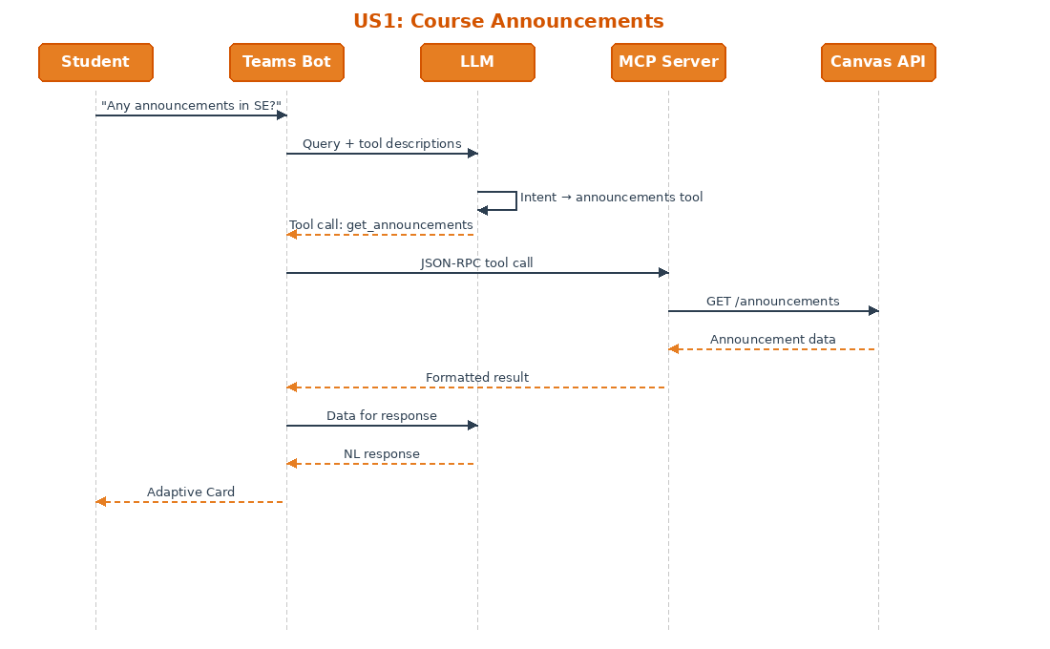
UC2: Assignment feedback (FR-02, FR-05). A student asks about teacher feedback on a recent assignment. The LLM identifies the intent and selects the relevant MCP tool, returning the most recent submission if no assignment is specified. Success: does the chatbot return teacher feedback and comments?
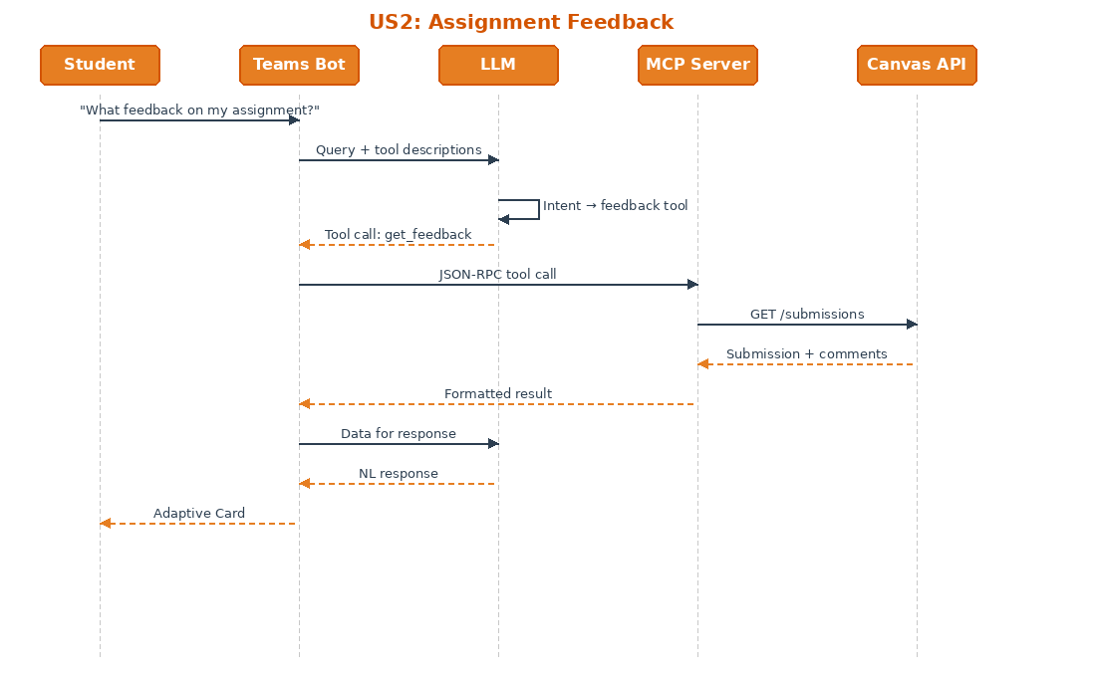
UC3: First-time OAuth2 connection (FR-04). A student sends any Canvas query for the first time. No token exists, so the bot displays an OAuth login card. The student authorizes, the bot stores the tokens, and the original query is fulfilled. This flow runs once per student. Success: can a student authenticate using standard OAuth2?
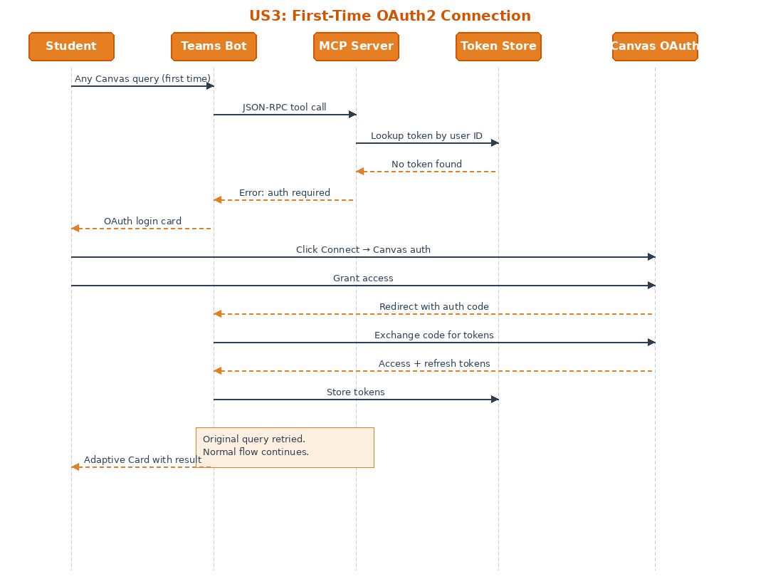

2.5 Breakdown of the Project
Sprint | Focus | Deliverables
Sprint 1 | Research and documentation | Research Document, Design Document, Project Plan
Sprint 2 | Research continuation, document polishing, basic demo | Updated research and design docs, basic Canvas polling demo
Sprint 3 | Feature completion | All four data types working, LLM query handling
Sprint 4 | Adaptive Cards and testing | Teams display integration, test results
Sprint 5 | Polish and delivery | Bug fixes, documentation, demo video, presentation
Sprint 6 | Buffer | Available if earlier sprints overrun

2.6 Time Plan
Each team member contributes approximately 40 hours per sprint. Total hours per person across five sprints: 200 hours. Total team hours (three members): 600 hours.
Sprint | Start | End | Demo | Hrs/person
Sprint 1 | 10 March 2026 | 28 March 2026 | 19 March | 40
Sprint 2 | 31 March 2026 | 18 April 2026 | 18 April | 40
Sprint 3 | 21 April 2026 | 9 May 2026 | 9 May | 40
Sprint 4 | 11 May 2026 | 29 May 2026 | 29 May | 40
Sprint 5 | 1 June 2026 | 19 June 2026 | 19 June | 40
Final |  | 20 June 2026 | TBD

3. Project Organisation

3.1 Team Members
Name | Role | Responsibilities
Danilo Pasecinic | Coordinator | Technical direction, architecture review, stakeholder alignment.
Kaan Secen | Developer | LLM layer, prompt engineering, Adaptive Cards.
Iskren Zhechev | Developer | MCP server, Canvas API, OAuth2, documentation.
Koen Janssen | Stakeholder | Requirements, sprint reviews, CY2 domain knowledge.
Patrick IJntema | Software Expert | Technical depth validation, KPI assessment.
Wilrik Loose | Software Expert | Technical depth validation, KPI assessment.

3.2 Communication
Stand-ups happen Monday and Thursday at 10:00, in person at TQ. Stakeholder demos run every three weeks at sprint end with Koen Janssen. Retrospectives follow each demo using Start/Stop/Continue format. Ad-hoc questions go through the Microsoft Teams group chat. Non-blocking questions wait until the next stand-up.

3.3 Test Environment
Development happens locally; deployment targets CY2’s own development environment (Stakeholder Clarification Notes). The local environment uses Docker containers for the MCP server and dependencies. A Canvas test account on the Fontys instance and a Teams test tenant for Adaptive Cards testing are both still to be arranged. OpenAI API keys are managed per developer. CI/CD is configured in Sprint 2 using GitHub Actions: TypeScript compilation, linting, unit tests, and Docker build verification on every push to main.

3.4 Configuration Management
The repository is hosted on GitHub with a protected main branch. Feature branches follow the naming convention feat/[short-description]. Pull request reviews catch issues before merge. Commit messages use conventional commit format (feat:, fix:, docs:, refactor:). Releases are tagged at each sprint demo: v0.1.0, v0.2.0, and so on.

4. Finance and Risks

4.1 Cost Budget
CY2 provides requirements, feedback, domain expertise, and access to their development environment for deployment. They do not provide API credits. Development costs per developer are under 10 EUR total, covering OpenAI API calls during development. GitHub free tier and local Docker cover everything else.

4.2 Risks
The table below lists the highest-impact risks. Canvas API access and OAuth2 complexity are the most critical because both block core functionality. Sprint 1 prioritises resolving these through early contact with Fontys IT and prototype testing.
Risk | Detection | Mitigation | Fallback
Canvas API access not arranged | No credentials by Sprint 1 end | Contact Fontys IT early | Mock responses for Sprint 2
OAuth2 complexity | Auth flow fails in prototype | Build prototype in Sprint 1 | Personal access tokens
Teams test tenant unavailable | No access by Sprint 3 | Request from Koen early | Microsoft online designer
LLM hallucination | LLM returns fabricated data | Validate against API response | Strict schema validation
Team member unavailable | Extended absence | Document all work in GitHub | Sprint 6 buffer

5. Other

5.1 Glossary
Term | Definition
MCP | Model Context Protocol. Open protocol for LLM-to-tool connections.
FastMCP | TypeScript framework for building MCP servers. Specified by CY2 for prototyping.
LLM | Large Language Model. AI system that interprets natural language queries.
Canvas LMS | Learning Management System used by Fontys for grades, assignments, announcements.
OAuth2 | Authorisation framework for accessing user data without exposing credentials.
Adaptive Cards | Microsoft card format for displaying rich content in Teams.

5.2 Related Documents
The Research Document answers RQ1 through RQ7 and contains the Canvas API analysis, MCP protocol investigation, and OAuth2 research. The Design Document covers system architecture, component diagrams, and security design. The Team Working Agreement defines stand-up times, communication norms, and task ownership. Individual Competence Documents map KPI targets and evidence for each team member.

5.3 References
Canvas LMS. (n.d.). Canvas REST API documentation. https://canvas.instructure.com/doc/api/
Canvas LMS. (n.d.). Canvas GraphQL API documentation. https://canvas.instructure.com/doc/api/graphql.html
CY2. (n.d.). About CY2 IT Services. https://www.cy2.nl/
ICT Research Methods. (n.d.). DOT Framework. https://ictresearchmethods.nl/
Microsoft. (2018). Adaptive Cards documentation. https://adaptivecards.io/
Model Context Protocol. (2024, November). MCP specification. https://modelcontextprotocol.io/
OpenAI. (2020). API documentation. https://platform.openai.com/docs/
punkpeye. (2025). FastMCP: A TypeScript framework for MCP servers (v3.31.0) [Software]. GitHub. https://github.com/punkpeye/fastmcp
Anthropic. (2024, November 25). Introducing the Model Context Protocol. https://www.anthropic.com/news/model-context-protocol

